**<Muscial Dustbin>**

|  |  |  |  |
| --- | --- | --- | --- |
| **Programme:** | **Problem based project** | **Level:** | Sec 3 |
|  |  |  |  |
| **Theme / Challenge Statement:** | **Innovative ideas to littering** | **Summary**  School intends to use the micro:bits during the CCA training. The CCA is Media Innovation Club which trains students in a number of areas such as photography, videography, video editing, mobile apps development, scratch programming, 3D modelling and printing.  The school intends to use the micro:bits to programme a ‘talking/musical’ dustbin. The idea is to encourage students to throw their waste into the bins rather than leave it lying around for the cleaners to clean. This would be a subject in the area of Citizenship and Character Education.  As the CCA already has 2 levels undertaking a mobile apps development course in Term 3, I have a handful of 5 Sec 3 students who will then undertake this project. |  |

|  |
| --- |
| <Please insert a photo here that is representative of the lesson idea. This photo will be used as the thumbnail of the lesson idea when it is posted on the Digital Maker website.> |

|  |  |
| --- | --- |
| **Prior Knowledge:** | Students should already know:  1. simple programming such as Scratch  2. electrical wiring skills  3. design and building prototypes |
| **Learning Objectives:** | By the end of the lesson, students should be able to:  1. programme Micro:bits using online programming  2. integrate the programmable chip into a functional product  3. |

|  |  |  |  |
| --- | --- | --- | --- |
| **Time** | **Teacher Activities** | **Purpose** | **Resources Needed** |
| **Introduction/Pre-activity** | | | |
| Lesson 1 | Teacher provides lesson on the functions of Micro:Bits and its capability through the sharing of slides provided at the educator’s training at Microsoft. | For student awareness and appreciation. | * Micro:Bit * Computers * Slides on functions of Micro:Bit |
| **Lesson development/Main activities** | | | |
| Lesson 2 | Teacher highlights the various functional blocks from the online programming that allows students to “talk” to the chip. | This allows students to better understand the available features / functionalities of the micro:bits | * Micro:Bit * Computers |
| Lesson 3 | Teacher gets students to create simple tasks like lighting up the LEDs and playing of music using Micro:Bits  Teacher also demonstrated how to create a counter on the Micro:Bit. | Students get to simulate a task given to the Micro:Bit via programming.  Students will be able to see the LEDs light up according to their programming instructions. | * Micro:Bit * Computers |
| Lesson 4 | Teacher demonstrates the use of peripherals such as sensors to be attached to the Micro:Bit. This also includes connection using “BOB”.  In this lesson, students are taught the various contact points that power up the Micro:Bits and the points that read signals. | In this lesson, students connect wires from the chip to external peripheral such as a sensor. | * Micro:Bit * BOB * Crocodile clips * Computers |
| Lesson 5 | Student led activity | Student creates a simple melody to play when the dustbin senses a litter. | * Micro:Bit * Computers |
| Lesson 6 | Student led activity | Student uses an auxiliary amplifier to boost the sound of the melody created in Lesson 5. | * Micro:Bit * BOB * Crocodile clips * Computers * Speakers |
| **Closure and consolidation/Post-activity** | | | |
| Lesson 7 | Teacher and students conducted a product testing to ensure reliability.  Teacher and students conducted a consolidation on the challenges and the next lap to further the project capabilities. |  |  |
| School Open House | Students had the opportunity to showcase their work at the Media Innovation Booth during the school’s open house in Nov 2017 |  |  |

|  |  |  |  |
| --- | --- | --- | --- |
| **List of Projects (5 – 10 projects if possible) created by Students** | | | |
|  |  |  |  |
|  |  |  |  |
|  |  |  |  |
|  |  |  |  |
|  |  |  |  |

Please send this template, together with any additional resources, e.g. Powerpoint slides, worksheets and .hex file, to: [digital_maker@imda.gov.sg](mailto:digital_maker@imda.gov.sg).

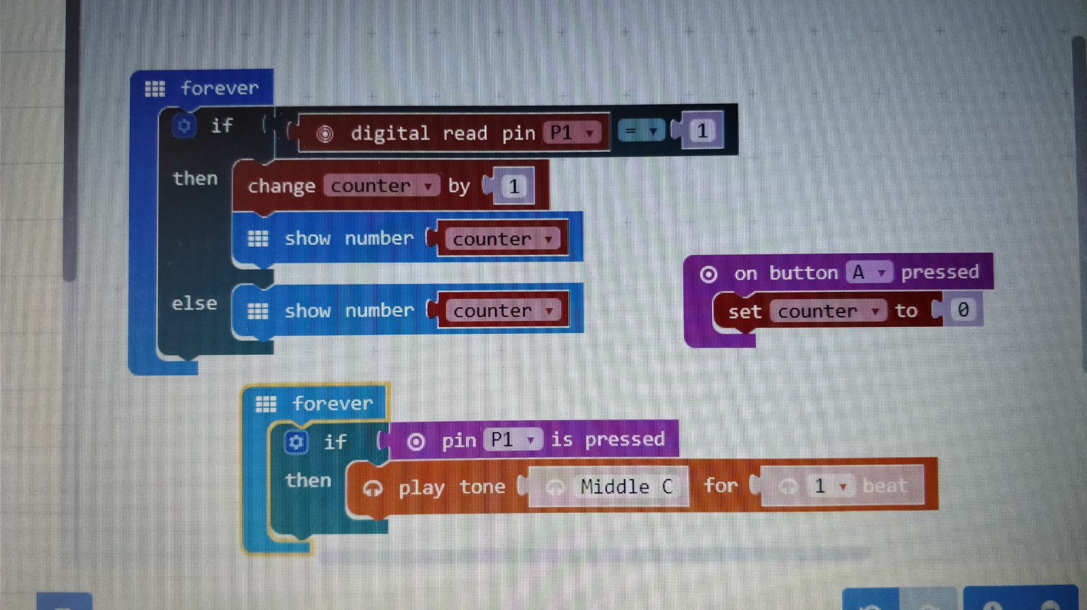

|  |
| --- |
| **Contributed by:**  Name of School: Kranji Secondary School  Name of Teacher (Optional): Chan Mun Leong Jeremy  Date: 15 Feb 2018 |